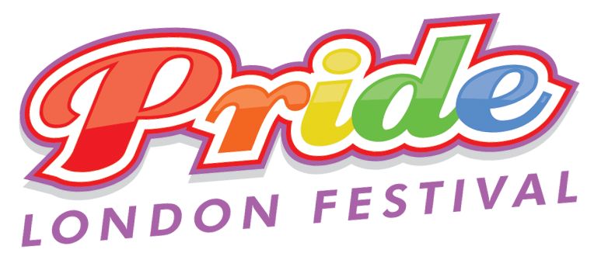  Press Release  Board Announcements  To All Members of our Community London,Canada  info@pridelondon.ca | January 28, 2025  Press Release London Ontario  To All Members, Media and Partners  It is with great pleasure we are happy to introduce our 2025 Pride Board of Directors:  Robyn Hodgson - President  Frederick Hood - Vice President  Eric Knight - Treasurer  Marley Hinrichsen - Secretary  Nick Veal - Director (Membership and Volunteers)  It has been a laborious first 8 weeks, and it was difficult having only a small transition team from the previous board. With our gratitude, we would like to thank Chris Baluk and Mark Beacock for their support and dedication as we work to transfer all of the board functions they were juggling.  It is only today that I am writing as the final communication piece has been completed, and we have access to all of the Meta accounts (Facebook, Instagram) which many of you use to connect with us. We have also expanded into the Bluesky platform, and look forward to connecting with all of our members who are choosing it as their preferred source of social media.  In our Nov 21 2024 AGM we passed several bylaw revisions, including expanding the size of the Board to 11 Directors, and enshrining quarterly general meetings to allow members to connect and participate. We have scheduled our first General Meeting for March 31 2025, and additional communication will be coming through all sources: e-mail, social media with our notification terms set out in the bylaws.  We are also asking for anyone interested in serving on the board to reach out and connect with us. In order to be considered, you must be a member in good standing for 60 days, and would encourage anyone interested to ensure their membership is up to date. If you have questions, please reach out to info@pridelondon.ca  We have also heard only having the festival in July leaves the rest of the year boring, lonely, or in some cases isolated. We are happy to share that we have a small Winter Pride scheduled for February 16 2025 at Palasad Social Bowl. This falls on the Family Day weekend, and we know many of our community don’t have accepting family, so our theme is “Chosen Family”.  With their consent, PFLAG/Trans* London - who operate London Queer Food Bank are partnering with us to ask you, if you are able, to bring a non-perishable food item so we can stock the shelves, and make sure none of us are going hungry.  Thank you for your patience as we plan our events for 2025!  The Board of Directors, Pride London Festival

